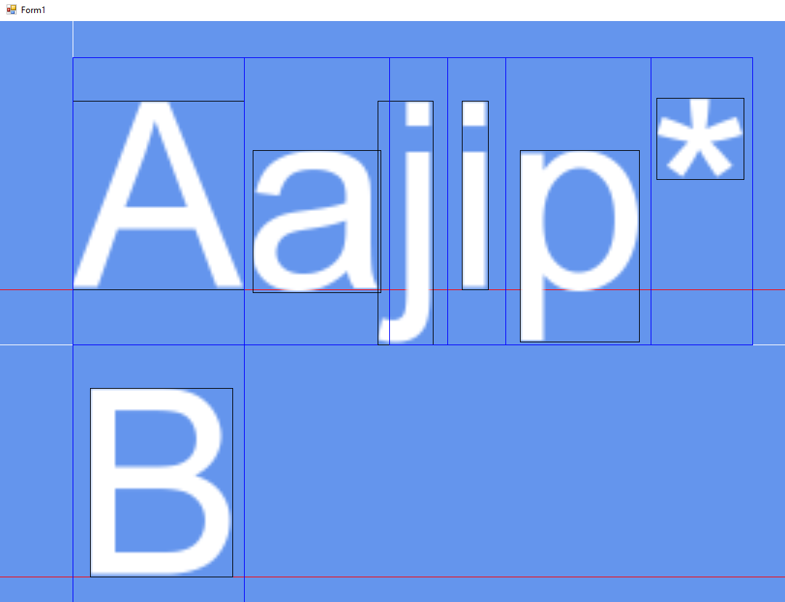Origin = distance of first char from screen’s origin position [0,0]
Where tex coordinates =[X,Y,Width,Height]/TextureSize
Offset + Size
Origin
Offset
Xadvance
Base
LineHeight
Size = same of tex coordinate [Width,Height]
Offset = distance from [origin + sum(xadvance foreach line’s chars)], or topleft corner of destination rectangle

